Create External Table

Count Credit Good and Credit Bad (1 for Good, 0 for Bad)

Count Gender (F for female, M for male) for credit good group

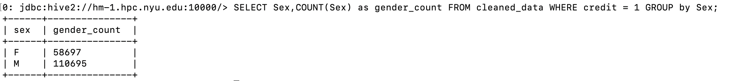

Count housing (1 for own house, 0 for non-own house) for credit good group

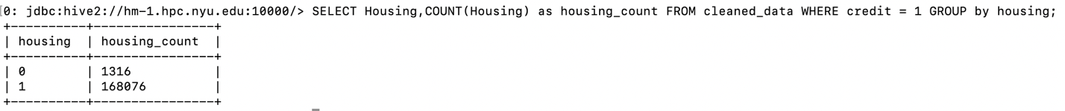

Count employment (1 for have job, 0 for have no job) for credit good group

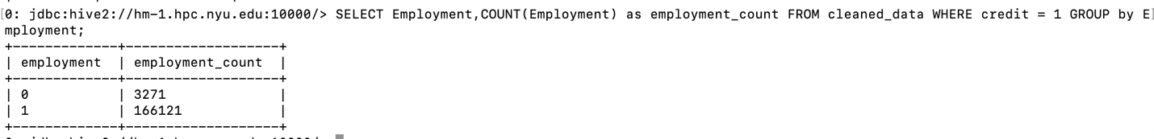

Count Age Group for credit good group

Calculate average monthly income to credit good group

